DGS-3630 Group L3 Unicast Test

# Result

* Group L3 Unicast installation successfully and chain to L2 Interface fine
* Flow to go to L3 Unicast Group successfully

# Environment

|  |  |
| --- | --- |
| ONOS Version | 2.2.0.rc1 |
| ONOS OpenFlow Driver | Default |
| DGS-3630 | Firmware 2.22.B007 |

|  |
| --- |
| winlab@root > summary  node=127.0.0.1, version=2.2.0.rc1 clusterId=default-7313 nodes=1, devices=1, links=0, hosts=0, SCC(s)=1, flows=4, intents=0 winlab@root > devices  id=of:000078321bdf7600, available=true, local-status=connected 1h43m ago, role=MASTER, type=SWITCH, mfr=D-Link Corporation, hw=DGS-3630-28TC H/W:A1, sw=Runtime:2.22.B007, serial=RZYG1HC000100, chassis=78321bdf7600, driver=default, channelId=192.168.20.201:1617, managementAddress=192.168.20.201, protocol=OF_13 |

## ONOS Apps Activation

|  |
| --- |
| winlab@root > apps -s -a  * 6 org.onosproject.hostprovider 2.2.0.rc1 Host Location Provider * 7 org.onosproject.lldpprovider 2.2.0.rc1 LLDP Link Provider * 8 org.onosproject.optical-model 2.2.0.rc1 Optical Network Model * 9 org.onosproject.openflow-base 2.2.0.rc1 OpenFlow Base Provider * 10 org.onosproject.openflow 2.2.0.rc1 OpenFlow Provider Suite * 20 org.onosproject.drivers 2.2.0.rc1 Default Drivers * 80 org.onosproject.proxyarp 2.2.0.rc1 Proxy ARP/NDP * 104 org.onosproject.gui2 2.2.0.rc1 ONOS GUI2 |

# Pipeline

DGS-3630 Group L3 Unicast would go through the pipeline as following:

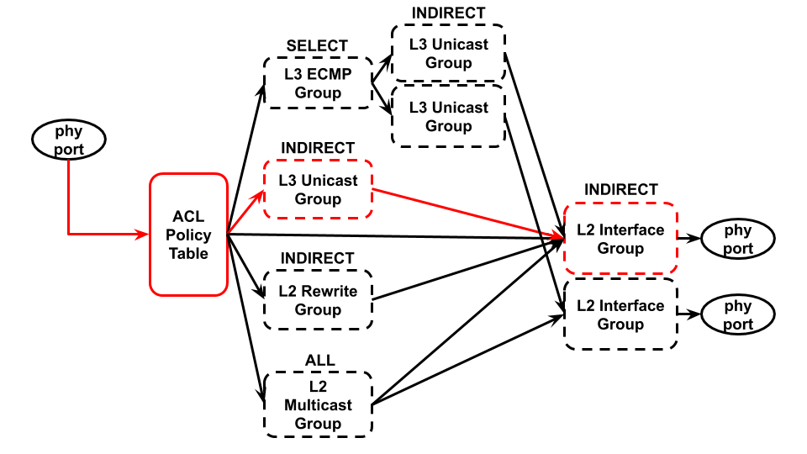

# Specific Format Requirment

Referring to the Spec. “*M2 (2019) > OpenFlow Test > DGS-3630 > Official Document > Appendix - OpenFlow Object Details.pdf*”, here grab the content and make a simple explain for this test using.

### 2.4 L3 Unicast Group Entry Type

|  |  |
| --- | --- |
| Field | Description |
| Group Identifier | A 32 bit unsigned integer uniquely identifying the group on the  OpenFlow switch. The naming rule is shown in Table L3 Unicast  Group Entry Naming Conversion. |
| Group Type | Indirect |
| Counters | Per-group entry counters are specified. |
| Action | Buckets Support single action bucket. |

### L3 Unicast Group Entry Naming Conversion

|  |  |  |
| --- | --- | --- |
| Field | Bits | Description |
| ID | [27:0] | Index to differentiate group entries of this type. |
| Kind | [31:28] | 2 (L3 Unicast) |

* In this test, we use the id as following for L3 Unicast Group:

|  |  |  |  |  |  |  |  |  |  |  |  |  |  |  |  |  |  |  |  |  |  |  |  |  |  |  |  |  |  |  |  |
| --- | --- | --- | --- | --- | --- | --- | --- | --- | --- | --- | --- | --- | --- | --- | --- | --- | --- | --- | --- | --- | --- | --- | --- | --- | --- | --- | --- | --- | --- | --- | --- |
| Kind | | | | ID (use as index) | | | | | | | | | | | | | | | | | | | | | | | | | | | |
| 31 | 30 | 29 | 28 | 27 | 26 | 25 | 24 | 23 | 22 | 21 | 20 | 19 | 18 | 17 | 16 | 15 | 14 | 13 | 12 | 11 | 10 | 9 | 8 | 7 | 6 | 5 | 4 | 3 | 2 | 1 | 0 |
| 210 | | | | choose slef-defined number as a index: 110 | | | | | | | | | | | | | | | | | | | | | | | | | | | |
| 0 | 0 | 1 | 0 | 0 | 0 | 0 | 0 | 0 | 0 | 0 | 0 | 0 | 0 | 0 | 0 | 0 | 0 | 0 | 0 | 0 | 0 | 0 | 0 | 0 | 0 | 0 | 0 | 0 | 0 | 0 | 1 |
| 23 | 22 | 21 | 20 | 211 | 210 | 29 | 28 | 27 | 26 | 25 | 24 | 23 | 22 | 21 | 20 | 215 | 214 | 213 | 212 | 211 | 210 | 29 | 28 | 27 | 26 | 25 | 24 | 23 | 22 | 21 | 20 |

### L3 Unicast Group Entry Bucket Actions

|  |  |
| --- | --- |
| Field | Description |
| Group | Must chain to a L2 Interface group entry. ***Required.*** |
| Decrement TTL | Decrement TTL.  *Note: it not support checking invalid TTL. |
| Set-Field | Set ETH_DST, ETH_SRC and VLAN_ID fields. ***Required.*** |

* Vendor support “Decrement TTL” field from ONOS 1.15.0
* In this test, we should put the field “DEC_TTL”, “ETH_DST”, “ETH_SRC” and “VLAN_ID” in L3 Unicast group action.
* Another group action is “group id” since L3 Unicast group should chain to L2 Interface group for DGS-3630 pipeline.

### L3 Unicast Group Entry Counters

|  |  |
| --- | --- |
| Field | Description |
| Reference Count (flow entries) | Number of flow or group entries currently referencing this group entry. |
| Duration (seconds) | Seconds since this group entry was installed |

# Test Steps

## Step1. Install L2 Interface Group

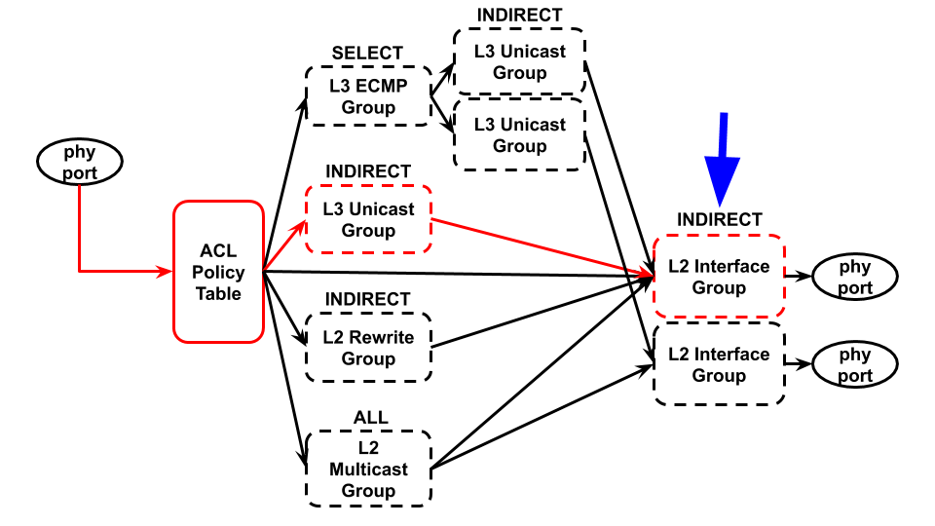

The group id as following for L2 Interface Group:

|  |  |  |  |  |  |  |  |  |  |  |  |  |  |  |  |  |  |  |  |  |  |  |  |  |  |  |  |  |  |  |  |
| --- | --- | --- | --- | --- | --- | --- | --- | --- | --- | --- | --- | --- | --- | --- | --- | --- | --- | --- | --- | --- | --- | --- | --- | --- | --- | --- | --- | --- | --- | --- | --- |
| Kind | | | | Chain ID | | | | | | | | | | | | Interface ID | | | | | | | | | | | | | | | |
| 31 | 30 | 29 | 28 | 27 | 26 | 25 | 24 | 23 | 22 | 21 | 20 | 19 | 18 | 17 | 16 | 15 | 14 | 13 | 12 | 11 | 10 | 9 | 8 | 7 | 6 | 5 | 4 | 3 | 2 | 1 | 0 |
| 0 | | | | modify VLan id to 1010 | | | | | | | | | | | | 110 | | | | | | | | | | | | | | | |
| 0 | 0 | 0 | 0 | 0 | 0 | 0 | 0 | 0 | 0 | 0 | 0 | 0 | 0 | 0 | 1 | 0 | 0 | 0 | 0 | 0 | 0 | 0 | 0 | 0 | 0 | 0 | 0 | 0 | 0 | 0 | 1 |
| 23 | 22 | 21 | 20 | 211 | 210 | 29 | 28 | 27 | 26 | 25 | 24 | 23 | 22 | 21 | 20 | 215 | 214 | 213 | 212 | 211 | 210 | 29 | 28 | 27 | 26 | 25 | 24 | 23 | 22 | 21 | 20 |

* Kind=0, L2 Interface
* Chain ID=1, range is 1~4094
* Interface ID=1, for output port is 1

curl L2 Interface Group Entry:

|  |
| --- |
| $ curl -X POST --user onos:rocks -H "content-type:application/json" http://localhost:8181/onos/v1/groups/of:000078321bdf7600 -d @InterfaceGroup.json |

|  |
| --- |
| {   "type":"INDIRECT",  "appCookie":"0x10001",  "groupId":"65537",  "buckets":[  {   "treatment":{  "instructions":[  {  "type":"OUTPUT",  "port":"1"  }  ]  }   }   ] } |

## Step2. Install L3 Unicast Group

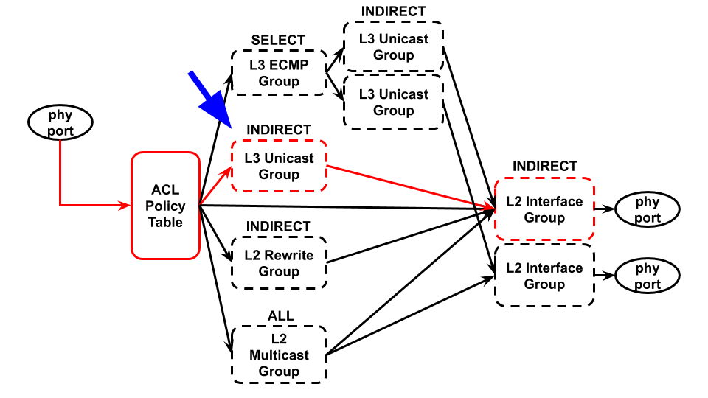

The group id as following for L3 Unicast Group:

|  |  |  |  |  |  |  |  |  |  |  |  |  |  |  |  |  |  |  |  |  |  |  |  |  |  |  |  |  |  |  |  |
| --- | --- | --- | --- | --- | --- | --- | --- | --- | --- | --- | --- | --- | --- | --- | --- | --- | --- | --- | --- | --- | --- | --- | --- | --- | --- | --- | --- | --- | --- | --- | --- |
| Kind | | | | ID (use as index) | | | | | | | | | | | | | | | | | | | | | | | | | | | |
| 31 | 30 | 29 | 28 | 27 | 26 | 25 | 24 | 23 | 22 | 21 | 20 | 19 | 18 | 17 | 16 | 15 | 14 | 13 | 12 | 11 | 10 | 9 | 8 | 7 | 6 | 5 | 4 | 3 | 2 | 1 | 0 |
| 210 | | | | choose slef-defined number as a index: 110 | | | | | | | | | | | | | | | | | | | | | | | | | | | |
| 0 | 0 | 1 | 0 | 0 | 0 | 0 | 0 | 0 | 0 | 0 | 0 | 0 | 0 | 0 | 0 | 0 | 0 | 0 | 0 | 0 | 0 | 0 | 0 | 0 | 0 | 0 | 0 | 0 | 0 | 0 | 1 |
| 23 | 22 | 21 | 20 | 211 | 210 | 29 | 28 | 27 | 26 | 25 | 24 | 23 | 22 | 21 | 20 | 215 | 214 | 213 | 212 | 211 | 210 | 29 | 28 | 27 | 26 | 25 | 24 | 23 | 22 | 21 | 20 |

* Kind=2, L3 Unicast
* ID=1

curl L3 Unicast Group Entry:

|  |
| --- |
| $ curl -X POST --user onos:rocks -H "content-type:application/json" http://localhost:8181/onos/v1/groups/of:000078321bdf7600 -d @UnicastGroup.json |

|  |
| --- |
| {   "type":"INDIRECT",  "appCookie":"0x20000001",  "groupId":"536870913",  "buckets":[  {  "treatment":{  "instructions":[  {  "type":"GROUP",  "groupId":"65537"  },  {  "type":"L3MODIFICATION",  "subtype":"DEC_TTL"  },  {  "type":"L2MODIFICATION",  "subtype":"ETH_DST",  "mac":"00:00:00:01:02:03"  },  {  "type":"L2MODIFICATION",  "subtype":"ETH_SRC",  "mac":"00:00:00:11:22:33"  },  {  "type":"L2MODIFICATION",  "subtype":"VLAN_ID",  "vlanId":1  }  ]  }  }  ] } |

## Step3. Install Flow to go to group entry

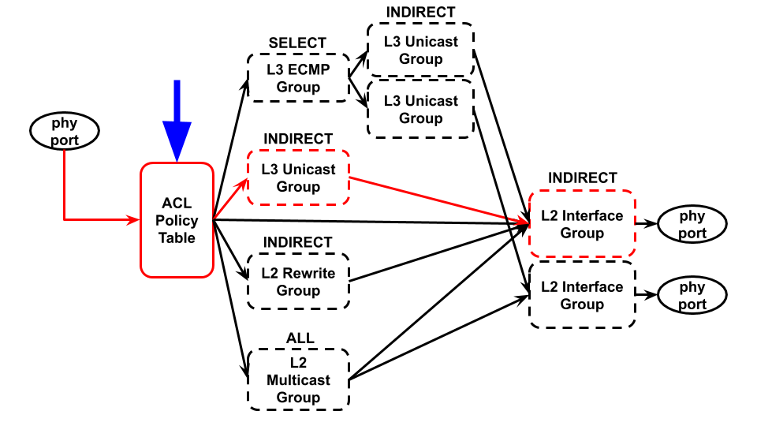

curl Flow Write-Actions:

|  |
| --- |
| $ curl -X POST --user onos:rocks -H "content-type:application/json" http://localhost:8181/onos/v1/flows -d @flow.json |

|  |
| --- |
| {   "flows":[  {   "priority":40001,  "timeout":0,  "isPermanent":true,  "deviceId":"of:000078321bdf7600",  "selector":{  "criteria":[  {  "type":"ETH_TYPE",  "ethType":"0x0800"  },  {  "type":"IPV4_DST",  "ip":"192.168.202.2/24"  }  ]  },   "treatment":{  "instructions": [],   "deferred": [  {  "type":"GROUP",  "groupId":"536870913"  }  ]  }   }   ] } |

# Conclusion

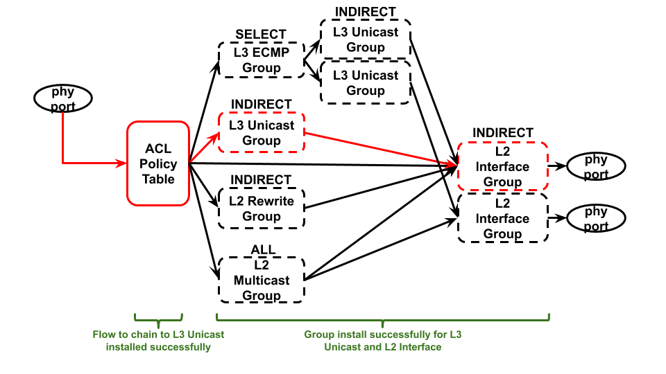

* Group L3 Unicast installation successfully and chain to L2 Interface fine
* Flow to go to L3 Unicast Group successfully

## ONOS GUI in Group Table

## ONOS GUI in Flow Table



## Test1 ping Test2

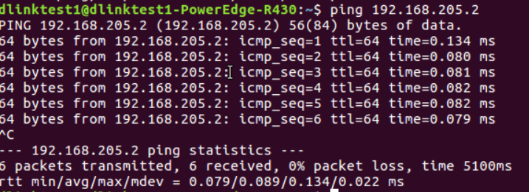

## Use tcpdump to monitor

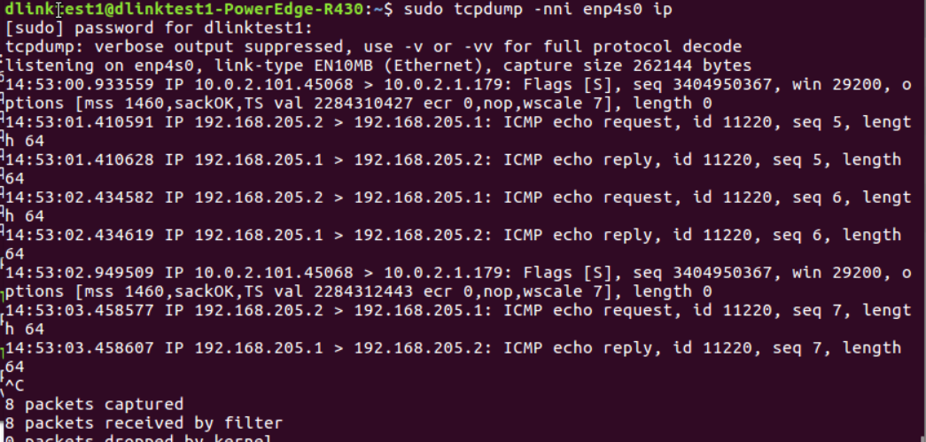

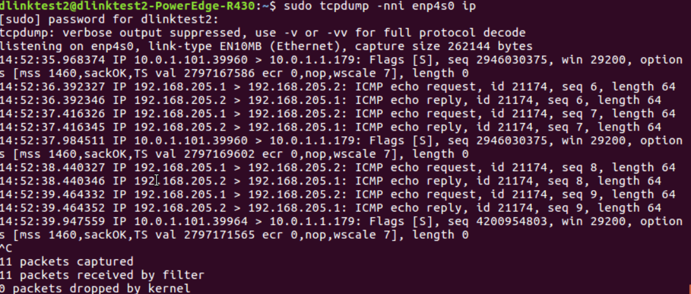

## DGS-3630 CLI in Group Entries

|  |
| --- |
| Switch#show openflow group-desc  === GroupId=65537, Hex=0x00010001 (L2 Interface, ChainId=1, Port=1) Type=Indirect, Reference count=1 Create time=2015-10-03 00:42:56 Bucket=1: Output=1  === GroupId=536870913, Hex=0x20000001 (L3 Unicast, Id=1) Type=Indirect, Reference count=1 Create time=2015-10-03 00:43:07 Bucket=1: Group=65537, Dec TTL, SrcMac=00-00-00-11-22-33, DstMac=00-00-00-01-02-03, VlanId=(1|present)  Total:2 |

## DGS-3630 CLI in Flow Entry

|  |
| --- |
| Switch#show openflow flows  === Match Fields:  ETH_TYPE=0x0800  IPV4_DST/Mask=192.168.202.0/255.255.255.0 Priority=40001 Cookie=0x00C000004FF4ACC0 Idle timeout=0, Hard timeout=0 Table=0, Packets=0, Bytes=0 Create time=2015-10-03 00:43:30 Instructions:  Write-Actions: Group=536870913  === Match Fields:  ETH_TYPE=0x0806 Priority=40000 Cookie=0x00010000DE52A92F Idle timeout=0, Hard timeout=0 Table=0, Packets=0, Bytes=0 Create time=2015-10-02 23:11:01 Instructions:  Apply-Actions: Output=CONTROLLER(Reserved)  Clear-Actions  === Match Fields:  ETH_TYPE=0x88CC Priority=40000 Cookie=0x00010000948A7777 Idle timeout=0, Hard timeout=0 Table=0, Packets=0, Bytes=0 Create time=2015-10-02 23:09:14 Instructions:  Apply-Actions: Output=CONTROLLER(Reserved)  Clear-Actions  === Match Fields:  ETH_TYPE=0x8942 Priority=40000 Cookie=0x00010000326F1D0A Idle timeout=0, Hard timeout=0 Table=0, Packets=0, Bytes=0 Create time=2015-10-02 23:09:14 Instructions:  Apply-Actions: Output=CONTROLLER(Reserved)  Clear-Actions  Total:4 |